Having several frequencies available in catalyst.
Go to CCC/information/Software
Look at the 2D Driver File Path
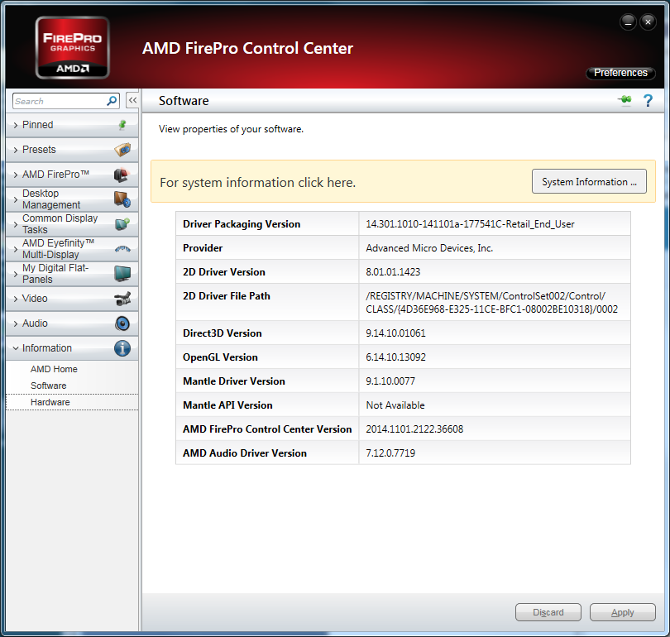
Open regedit (start/run/regedit)
Go to: HKEY_LOCAL_MACHINE\SYSTEM\CurrentControlSet\Control\Class\{4D36E968-E325-11CE-BFC1-08002BE10318}\
Then to the number shown in CCC at the end of 2D driver file path (in the screen shoot: /0002)
Be careful to be in CurrentControlSet and not in ControlSet002
In this key find the value: DalReportSingleSelectedTiming
Set it to 0 and reboot
Now you should see different frequency available in CCC.

