Unity Stereo 3D Rendering

Unity3D game engine users who want to create stereoscopic 3D content have the option to use a 3rd party rendering plugin by Vital Volkov called Stereoscopic 3D system for Unity
New XR Plugin Management System Support: https://github.com/widVE/UniCAVE/issues/18
Note: At this time the Cesium for Unity plugin does not appear to be compatible with Vital Volkov's stereo3D rendering plugin.

Plugin Installation Procedure
Step 1. Go to the Stereoscopic 3D system for Unity project's GitHub page. Click on the "Stereo3D.unitypackage" file in the list of files included in the repo. Then click the download icon to download the raw file.

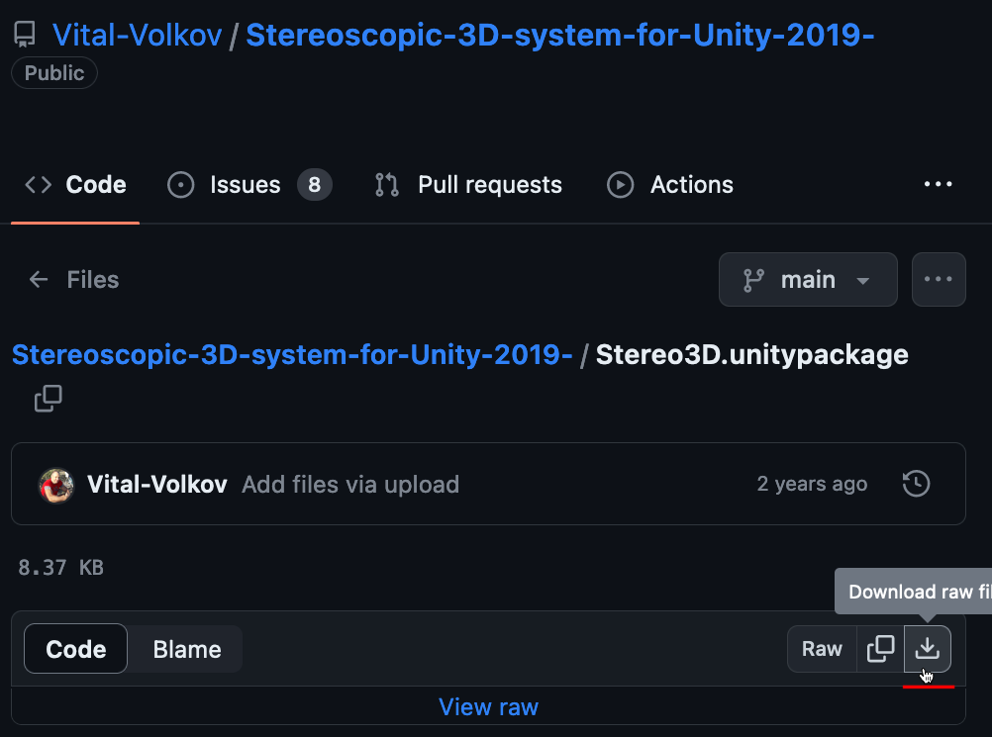

Step 2. Install Unity3D's Hub utility. Then use the following web URL to download the Unity 2021.3.19f1 release. (You need to copy/paste this URL into your web-browser for it to be handled correctly.)

unityhub://2021.3.19f1/c9714fde33b6

A download window will appear in the Unity Hub program:
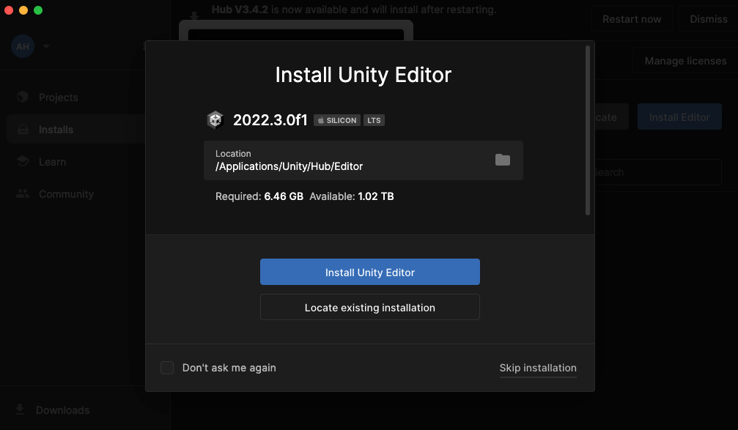

Step 3. After Unity3D is installed, create a new default project. A good choice if this is your first time using Unity is the "3D Sample Scene (URP)" example.

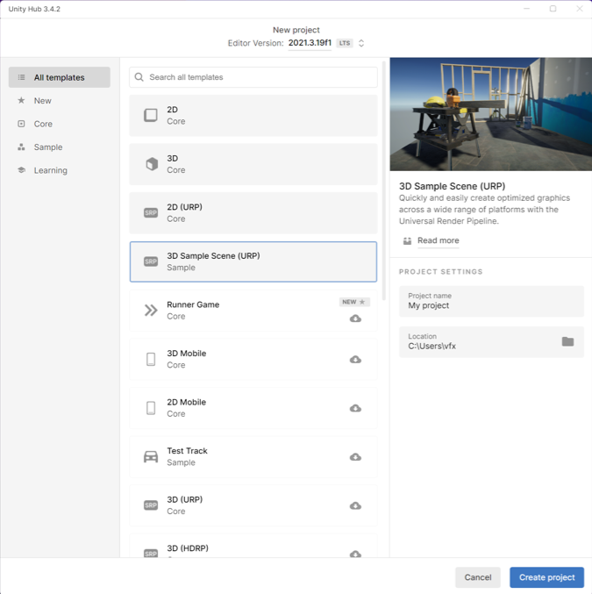

Unity will take a few minutes to create the new project.

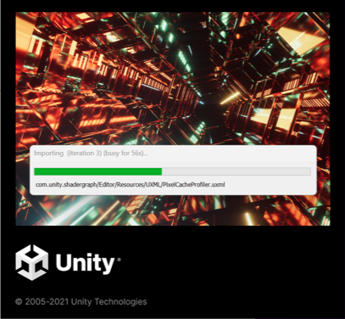

The "Stereo3D.unitypackage" file is imported using the "Assets > Import Package" menu. (For more information on importing packages check out the Unity docs.)

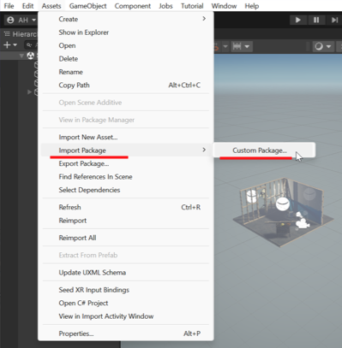

In the file browsing window select the "Stereo3D.unitypackage" item and click Open.
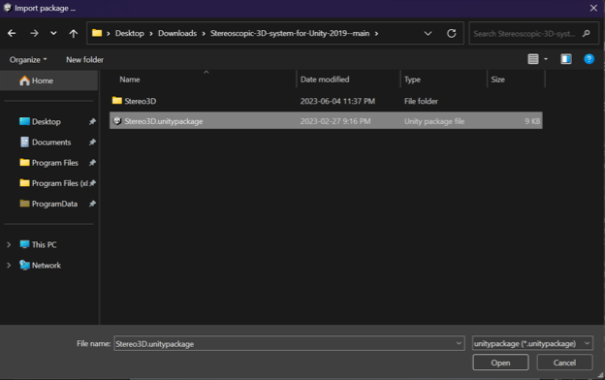
The Import Unity Package dialog shows you the content that will be installed. Click "Import" to continue.
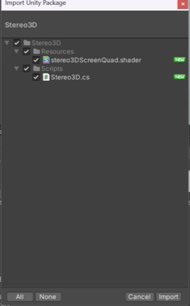

Step 4. We are now going to create the stereo camera. Select the "MainCamera" in the hierarchy view on the top left of the Unity3D user interface. Then click the "Add a component" button.
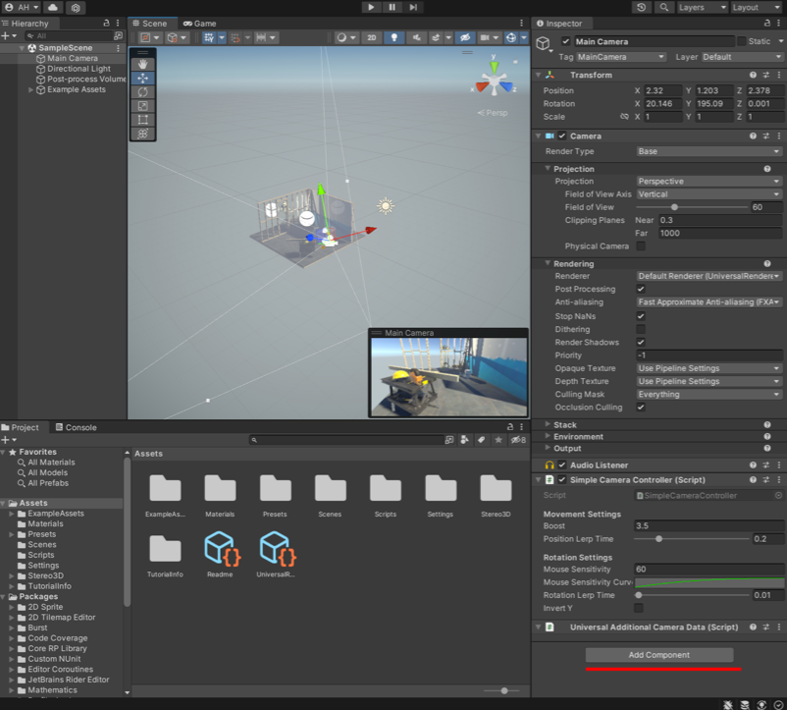

Navigate to the "Select Scripts > Stereo3D" menu item.
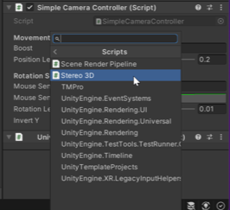

With the MainCamera selected, scroll down to the "Stereo3D" script section.
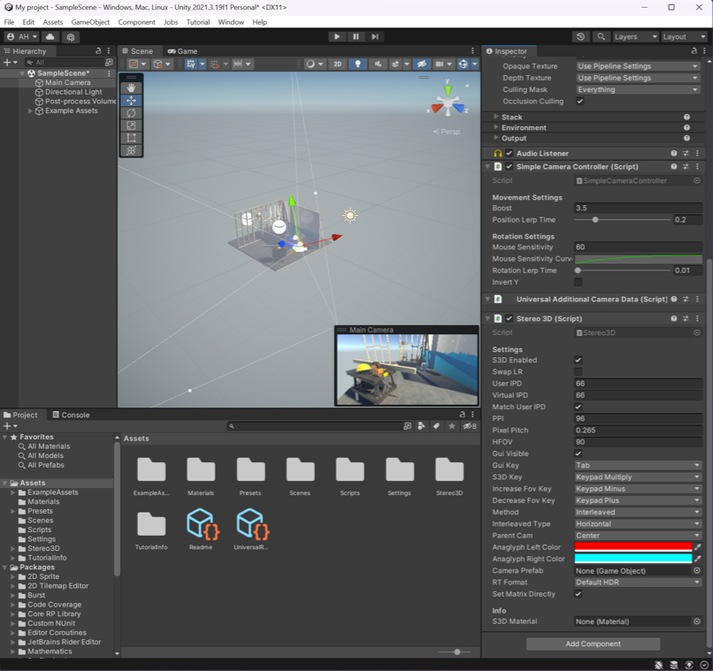
Click the "Play" button to start playing the scene. Double click on the game tab to maximise this view panel.

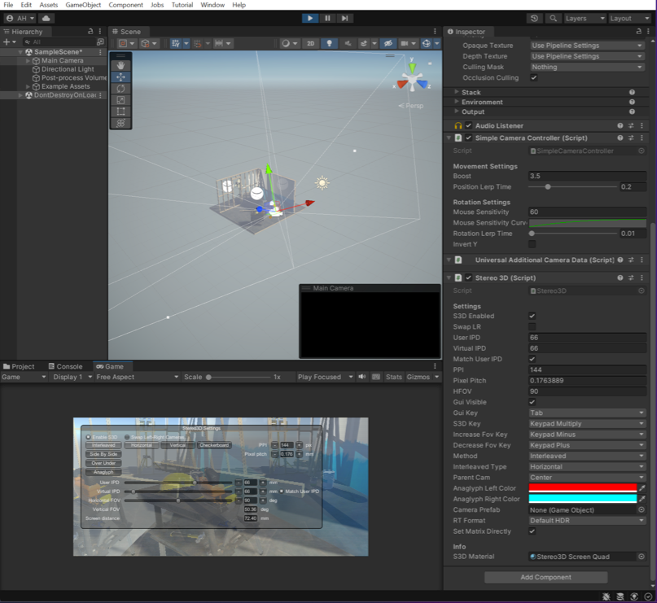

Enter the following initial settings for a 4k monitor:
S3D Enabled [x] (checked)
User IPD: 12.52
Virtual IPD: 59.05
Match User IPD [] (Unchecked)
PPI 96
Pixel Pitch 0.264
HFOC 95.56
Interleave Type: Anaglyph

Step 5. If you try to install Cesium for Unity you will get the following runtime error when combining the stereo 3D rendering toolset with Cesium:

Console Error: You are trying to read input using the UnityEngine input class but you have switched the active input handling to the input system package in the player settings.

This error relates to how the Stereo3D plugin has a HUD overlay window that takes user input at the same time as the Cesium plugin wants to use a new Unity "Input System" module.

There is an outstanding Cesium for Unity support ticket for multi-camera support:
- https://community.cesium.com/t/about-more-main-camera-in-unity/24433/4
- https://github.com/CesiumGS/cesium-unity/issues/327

Additionally, it appears that a "Culling mask" feature in the stereo camera rig might have been an additional compatibility issue.

